Arrow Function

* Declare function in a shorter form
* Lexically bind the context
* Usually anonymous but name can be inferred
  + <https://dmitripavlutin.com/javascript-arrow-functions-best-practices/#1-arrow-function-name-inference>
  + Lexical function name is useful for recursion, detaching event handlers, etc.

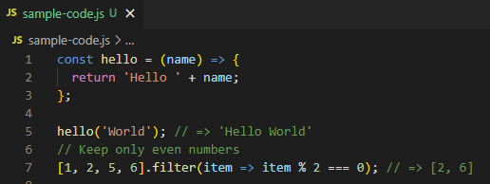

Lexical Scope

* Static scope
* Context is defined where the named variable or function is defined

Also arrow function doesn't provide the arguments object, opposed to a regular function. The missing arguments is fixed using ES2015 rest parameters:

